**Capstone Project (Week 2):**

**Applied Data Science Capstone by IBM/Coursera**

**Where to Open A New Chick-Fil-A in Austin**

Bryan Garrido

June 6, 2020

**1. Introduction**

**1.1 Background**

Chick-Fil-A is a fast food restaurant that was founded in 1946 and is the largest chain whose specialty is chicken sandwiches. It’s known for its speedy, respectful, friendly service as much as its food. The emphasis on customer service has made it a prime location for young families trying to wrangle kids and for anyone that truly wants food in a hurry. The menu at Chick-Fil-A is simple compared to other fast food options, but this works to its advantage. The limited options allow workers to serve customers faster. Each restaurant operates as a well-oiled machine that has double drive thru lanes, online ordering, as well as indoor dining. This shows in their financials as well. The average Chick-Fil-A restaurant grossed $4.4 million in 2016. This is $1.7 million more than any other fast food chain in the country. Given their success, people should be jumping at the opportunity to own their own Chick-Fil-A restaurant, but it’s not that easy. Chick-Fil-A hand picks people to operate its franchises and retains ownership of restaurant.

**1.2 Problem**

I met someone who was picked to operate a restaurant and is currently going through the training. The objective of this project is to identify areas in Austin, TX to open a new Chick-Fil-A restaurant.

**1.3 Interest**

The scope of interest is fairly limited in this case, especially given that only a handful of people have the privilege of being able to operate their own Chick-Fil-A restaurant. However, anyone seeking that opportunity may also be interested.

**2. Data Acquisition and Cleaning**

**2.1 Data Sources**

Utilization of the Foursquare API is required for this project. However, the results for several different queries were severely lacking. The queries returned results in the hundreds when it should be in the thousands. As such, I used restaurant inspection data from the City of Austin website that can be found [here](https://data.austintexas.gov/Health-and-Community-Services/Food-Establishment-Inspection-Scores/ecmv-9xxi). It contains inspection data for every venue that serves food in the city of Austin, starting in December 2017. I don't want to limit my search to only fast food restaurants. Most restaurants now offer take out if needing something quick and often when trying to decide where to eat, a limitation to fast food virtually never implemented.

**2.2 Data Cleaning**

The data is contained within a single table. I excluded any records that don’t have an address. This was limited to only one venue. There are a few problems with the dataset before it can be used in this project.

First, there are duplicate rows for individual venues. There is a record for each inspection performed since 2017. Using Excel, I deleted any duplicate rows based on ‘Restaurant Name’ and ‘Address’. This resulted in a total of 5107 venues.

Second, the latitude and longitude of each location is in the address feature. These need to be extracted and added as their own features. I used Excel formulas to perform this action. This resulted in two new columns. Checking for completeness, I found there are 449 (<10%) locations that didn’t have a latitude or longitude available in the address feature. I pulled these locations out and put them in second data set. I loaded this set into my jupyter notebook and used the geopy package to find the as many of the GPS coordinates as possible and then added these records to the original data set.

**3. Methodology**

**3.1 Calculation of Nearest Chick-Fil-A**

When looking at the map of venues in Austin, it’s hard to even know where to begin.

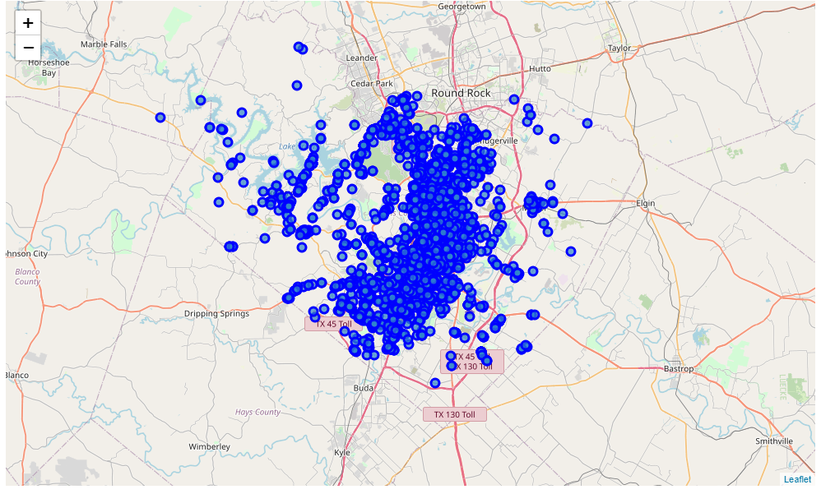

*Figure 1. Map of all food venues in Austin*

To eliminate some of the noise, I wanted to remove any location that is within 3 miles of Chick-Fil-A. This will give us a new map and show us where businesses are currently set up and aren’t having to compete with Chick-Fil-A. To do this, I created a new dataframe that only has the Chick-Fil-A restaurants in it. Then I wrote a function that will loop through each venue, calculate the distance to each Chick-Fil-A restaurant, and return the minimum distance. This creates a new feature that will be key to the analysis.

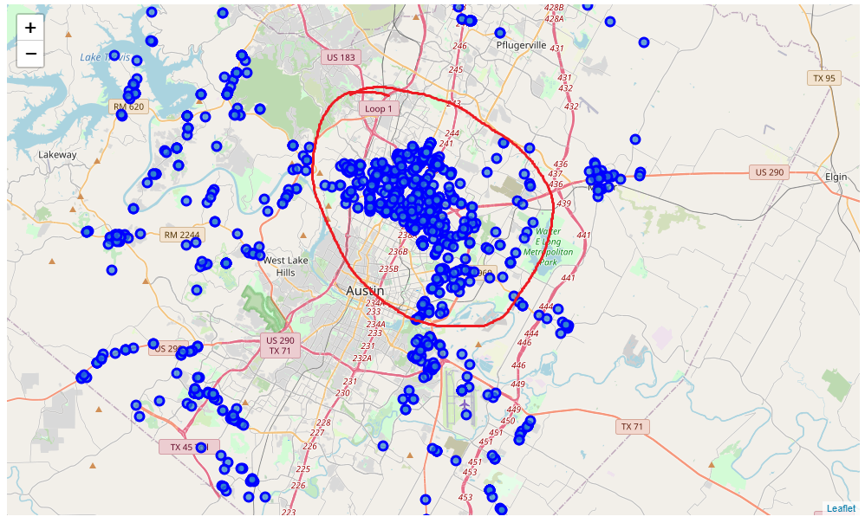

*Figure 2. Map of all food venues at least 3 miles away from the nearest Chick-Fil-A*

**3.2 Refining the Search**

Circled in red in Figure 2, there is large number of venues congregated in the North-Northwest area of Austin that are more than 3 miles from a Chick-Fil-A. I’m going to assume that the owners of these venues did some research when they chose to operate in this location and that there is a good customer base in this location. By limiting the data to this area, there are 622 food venues in this area alone.

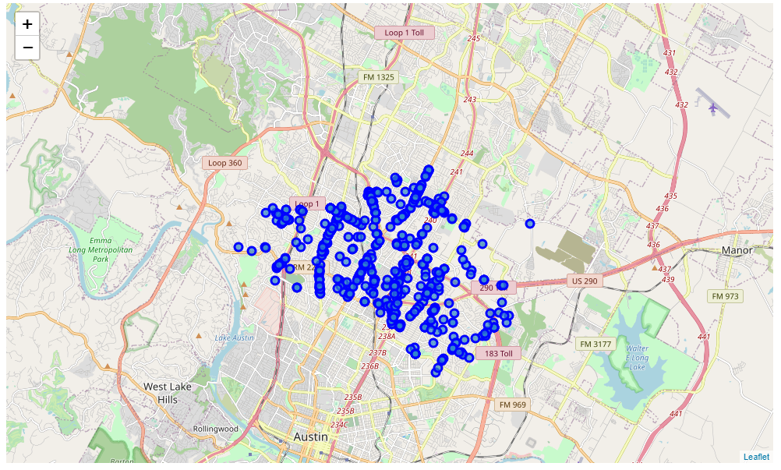

*Figure 3. Map of Venues in North-Northwest Austin*

**3.3 K-Means Clustering**

Now that the search has been refined, I used the k-means clustering algorithm to group the venues in this area. I used the elbow method to determine that the optimal k is k=4.

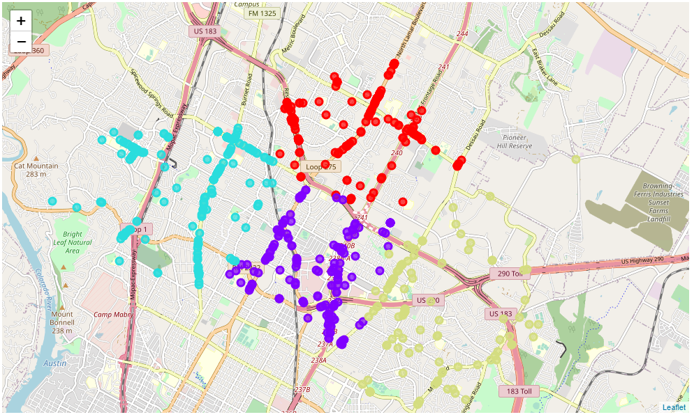

*Figure 4. Map of clusters*

**4. Results and Discussion**

|  |  |  |
| --- | --- | --- |
| **Cluster Color** | **Avg Distance from Nearest Chick-Fil-A (miles)** | **Restaurant Density** |
| Red | 3.70 | 163 |
| Purple | 3.80 | 151 |
| Teal | 3.48 | 186 |
| Olive Green | 4.38 | 122 |

*Table 1. Cluster Analysis*

From the analysis, we can see that Austin is known for its food for a reason. With over 5000 venues within just the Austin city limits, competition is steep. There is a big pocket in the North-Northwest area of Austin that doesn't have a Chick-Fil-A within 3 miles of any restaurant in the area. This is a prime area to pay attention to and look for opportunities. The purple cluster contains a college campus all of them are next to major roads and highways.

The result of this does not imply that these are the most optimal locations in the entire city of Austin. The purpose was only to find locations that are far enough away from a current operating Chick-Fil-A, that denizens may find it too far to travel, especially in Austin traffic.

**5. Conclusion**

Purpose of this project was to identify areas in Austin that do not have a nearby Chick-Fil-A in order to aid my acquaintance in finding a location to open a new restaurant. By calculating restaurant density and distance to the nearest Chick-Fil-A, we have identified an opportunistic area in North-Northwest Austin. Focusing on that area, clusters can be generated to further refine the search.

The final decision on the optimal location is to be made by my acquaintance. Additional factors, such as population density, major roads, major offices or campuses, real estate availability and economic factors (both social and real estate) within each cluster should be considered.